Milestone 1
Finalized Project Requirements & System Design Document

Table of Contents
1. Project Overview 4
2. Supported Platforms 4
2.1 Email Client 4
2.2 Operating System 4
2.3 Add-in Framework 4
2.4 Storage Infrastructure 4
3. Core Functional Requirements 5
3.1 Outlook User Interface Integration 5
3.1.1 Outlook Ribbon Toolbar 5
3.1.2 Context Menu Integration 5
3.2 Email Filing Mechanism 6
3.2.1 Email Storage Format 6
3.2.2 File Naming Convention 6
3.2.3 Attachment Handling 6
3.2.4 Multiple Filing Locations 7
3.2.5 Duplicate Detection 7
3.2.6 Filing Confirmation 7
3.3 Location Management 7
3.3.1 Add Location Interface 8
3.4 Suggested Locations 8
3.5 Search Functionality 8
3.5.1 Search Filters 8
3.5.2 Search Results 8
3.6 User Preferences 9
4. Non-Functional Requirements 9
4.1 Performance 9
4.2 Security 9
4.3 Reliability 10
4.4 Logging 10
5. Out of Scope (Phase 1) 10
6. System Architecture Overview 10
7. System Components 11
7.1 Outlook Add-in (Frontend) 11
7.2 Local Desktop Agent / Background Service 11
7.3 Email Data Retrieval 12
8. Data and Folder Structure 12
8.1 Storage Location 12
8.2 Configuration Data 12
9. Search Implementation 13
10. User Interface Screens 13
11. Expected Users 18
Conclusion 18

1. Project Overview
The objective of this project is to develop a custom email filing application that integrates directly with Microsoft Outlook. The application will allow users to manually file emails and their attachments into designated project folders stored on central mapped network drives.
The system will be used by approximately 50 staff members and must provide an intuitive interface within Outlook for filing, managing, and searching emails stored in shared project folders.
The solution will be implemented as a modern Outlook Web Add-in using web technologies and will integrate with a backend service responsible for performing file system operations on network drives.

2. Supported Platforms

2.1 Email Client
The application must support:
• Microsoft Outlook Desktop (Classic Outlook)
• Microsoft Outlook for Windows (New Outlook)

2.2 Operating System
Supported operating systems include:
• Windows 10
• Windows 11

2.3 Add-in Framework
The application will be implemented using:
• Office.js
• React.js
• TypeScript / JavaScript

2.4 Storage Infrastructure
Emails will be stored on central mapped network drives used by the organization for project document storage.
Example:
H:\Projects\
H:\Shared\

3. Core Functional Requirements

3.1 Outlook User Interface Integration
The system must integrate directly within the Outlook interface.

3.1.1 Outlook Ribbon Toolbar
A new toolbar section will be added to Outlook containing the following buttons:
• File Email – opens the email filing interface
• Search – opens the email search interface
• Options – opens the user preferences/settings panel
These buttons must be visible when viewing or reading an email.

3.1.2 Context Menu Integration
When a user right-clicks an email in Outlook (Inbox, Sent Items, or other folders), a new menu item will appear.
Menu structure:
File Email >
Suggested Locations
Personal Filing Location
More locations and options...
Suggested Locations
- The system will display the 10 most recently used filing locations.
Personal Filing Location
- A predefined folder used for personal email filing.
More locations and options
- Opens the full filing interface where users can browse and select filing locations.

3.2 Email Filing Mechanism
The application will allow users to manually file emails.
Filing Trigger
Emails are filed only when the user selects the File Email command.
There will be no automatic filing in Phase 1.

3.2.1 Email Storage Format
Emails must be saved in their original .msg format.
Example:
20260316_ProjectUpdate.msg

3.2.2 File Naming Convention
To avoid duplicate names or invalid characters, the system will use a standardized naming format:
YYYYMMDD_HHMMSS_Subject.msg
Example:
20260316_1030_ProjectMeeting.msg
Invalid characters in email subjects must be sanitized before saving.

3.2.3 Attachment Handling
Attachments will be stored alongside the email file.
Two storage options may be supported:
Option A
Attachments embedded within the .msg file.
Option B
Attachments extracted to a structured folder:
ProjectFolder/
Email.msg
Attachments/
file1.pdf
document.docx
The default behaviour will be configurable in user preferences.

3.2.4 Multiple Filing Locations
Users must be able to select multiple locations and file a single email to multiple folders simultaneously.

3.2.5 Duplicate Detection
If the same email is filed to a location where it already exists, the system must prompt the user with options:
• Overwrite existing file
• Rename the new file
• Skip filing

3.2.6 Filing Confirmation
After filing an email successfully, the user must receive visual confirmation indicating that the filing operation completed successfully.

3.3 Location Management
Users must be able to manage filing locations through a dedicated interface.
Location management features:
• Add new filing location
• Edit existing location
• Delete location
• Explore folder in Windows Explorer
• Assign location to a collection (e.g., Personal, Projects)
• Mark a location as default

3.3.1 Add Location Interface
When users click Add Location, a form must appear with the following fields:
• Location Type (Local or Network Folder)
• Folder Path
• Description
• Collection Name
Users must also be able to browse for folder locations using a folder selection dialog.

3.4 Suggested Locations
The application must maintain a list of the 10 most recently used filing locations.
These locations will appear automatically in the Suggested Locations menu when users right-click an email.

3.5 Search Functionality
The system will provide a dedicated interface allowing users to search filed emails stored across network locations.

3.5.1 Search Filters
Search criteria must include:
• Date Range (e.g., Past 6 Months)
• From
• To
• CC
• Subject
• Email Body
• Attachments indicator

3.5.2 Search Results
Search results must display:
• Email Subject
• Sender
• Recipient
• Sent Date
• File Location
Users must be able to:
• Open the stored email directly in Outlook
• View the folder path where the email is stored
• Sort results by date, sender, or subject

3.6 User Preferences
The application must provide a settings panel allowing users to configure filing behaviour.
Available preferences include:
• Move email to Deleted Items after filing
• Prompt user to file Sent Messages
• Mark emails as filed
• Configure attachment handling behaviour
• Configure default filing location

4. Non-Functional Requirements

4.1 Performance
• Filing an email should complete within 2–3 seconds.
• Search results should return within 1–2 seconds when indexed.

4.2 Security
The system must ensure secure handling of email data.
Requirements include:
• Respect Windows network folder permissions
• Only authorized users may access designated project folders
• Communication between the Outlook Add-in and backend service must use secure protocols (HTTPS)
• Email data must not be stored outside approved network drives.

4.3 Reliability
The system must gracefully handle errors including:
• Network drive unavailable
• Insufficient folder permissions
• File save failures
• Duplicate files
• Communication errors with the local service.

4.4 Logging
The system must maintain logs for troubleshooting.
The local agent will log:
• Email filing operations
• Search requests
• System errors
• Network access failures

5. Out of Scope (Phase 1)
The following features will not be included in the first phase:
• Deep content search within attachment files (PDF, Word, etc.)
• Microsoft SharePoint integration
• AI-based automatic email classification
• Automated email filing rules
These features may be considered in future project phases.

6. System Architecture Overview
To support both Classic Outlook and New Outlook, the system will be developed as a modern Outlook Web Add-in using web technologies.
Because Outlook Web Add-ins run in a sandboxed environment and cannot directly access local or network file systems, an additional service is required to perform file operations.

7. System Components

7.1 Outlook Add-in (Frontend)
The Outlook Add-in provides the user interface and integrates directly into Outlook.
Components include:
Manifest File
Defines:
• Ribbon buttons
• Context menu commands
• Permissions
• Add-in metadata

Taskpane and Dialog Interfaces
Built using React.js.
These interfaces provide:
• Email filing window
• Location management
• Search interface
• User preferences panel

7.2 Local Desktop Agent / Background Service
A lightweight local service will run on the user’s machine.
Responsibilities:
• Receive commands from the Outlook Add-in
• Retrieve email content via APIs
• Save emails and attachments to network drives
• Maintain search indexing data
This service acts as a bridge between the Add-in and the network file system.

7.3 Email Data Retrieval
The system will use Microsoft Graph to retrieve the full MIME content of emails and their attachments.
The Local Agent will process this data and store it in .msg format on the network drive.

8. Data and Folder Structure

8.1 Storage Location
Emails will be stored directly on the organization's mapped network drives.
Example structure:
NetworkDrive/
Projects/
ProjectA/
Emails/
20260316_ProjectUpdate.msg
ProjectB/
Emails/
20260316_ClientMeeting.msg

8.2 Configuration Data
User configuration and system metadata will be stored in:
• Central configuration file
or
• Lightweight database such as SQLite
Stored data includes:
• Recent filing locations
• Saved folder paths
• User preferences
• Search index metadata

9. Search Implementation
Searching large network folders can be slow. Therefore, a lightweight indexing system will be used.
The Local Agent will maintain an index containing:
• Email Subject
• Sender
• Recipients
• Sent Date
• File Path
The search interface will query this index to provide fast results without scanning all folders.

10. User Interface Screens
The application will include the following main screens:

Right-Click Menu
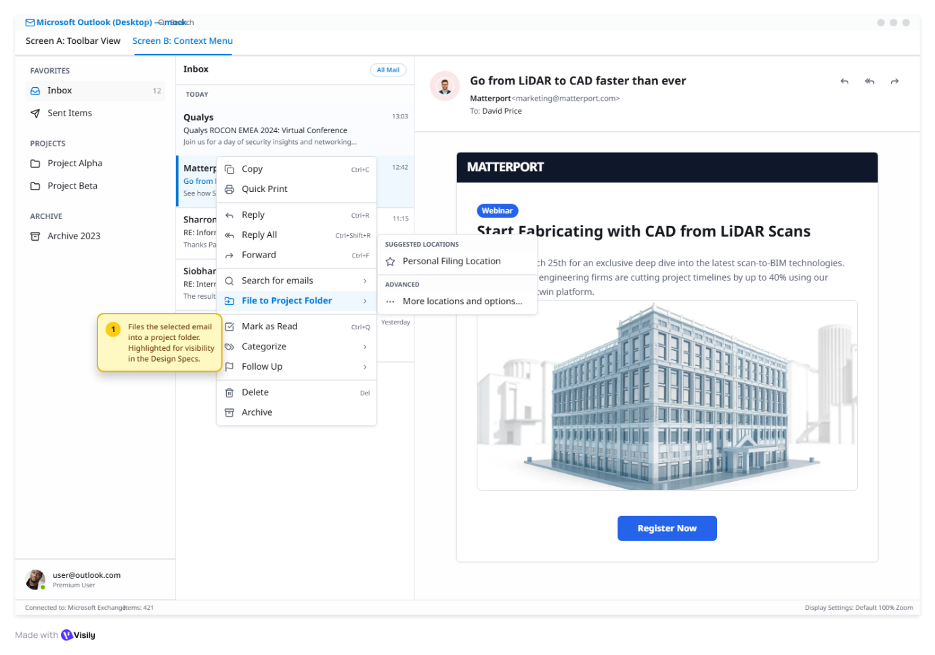

Toolbar Buttons
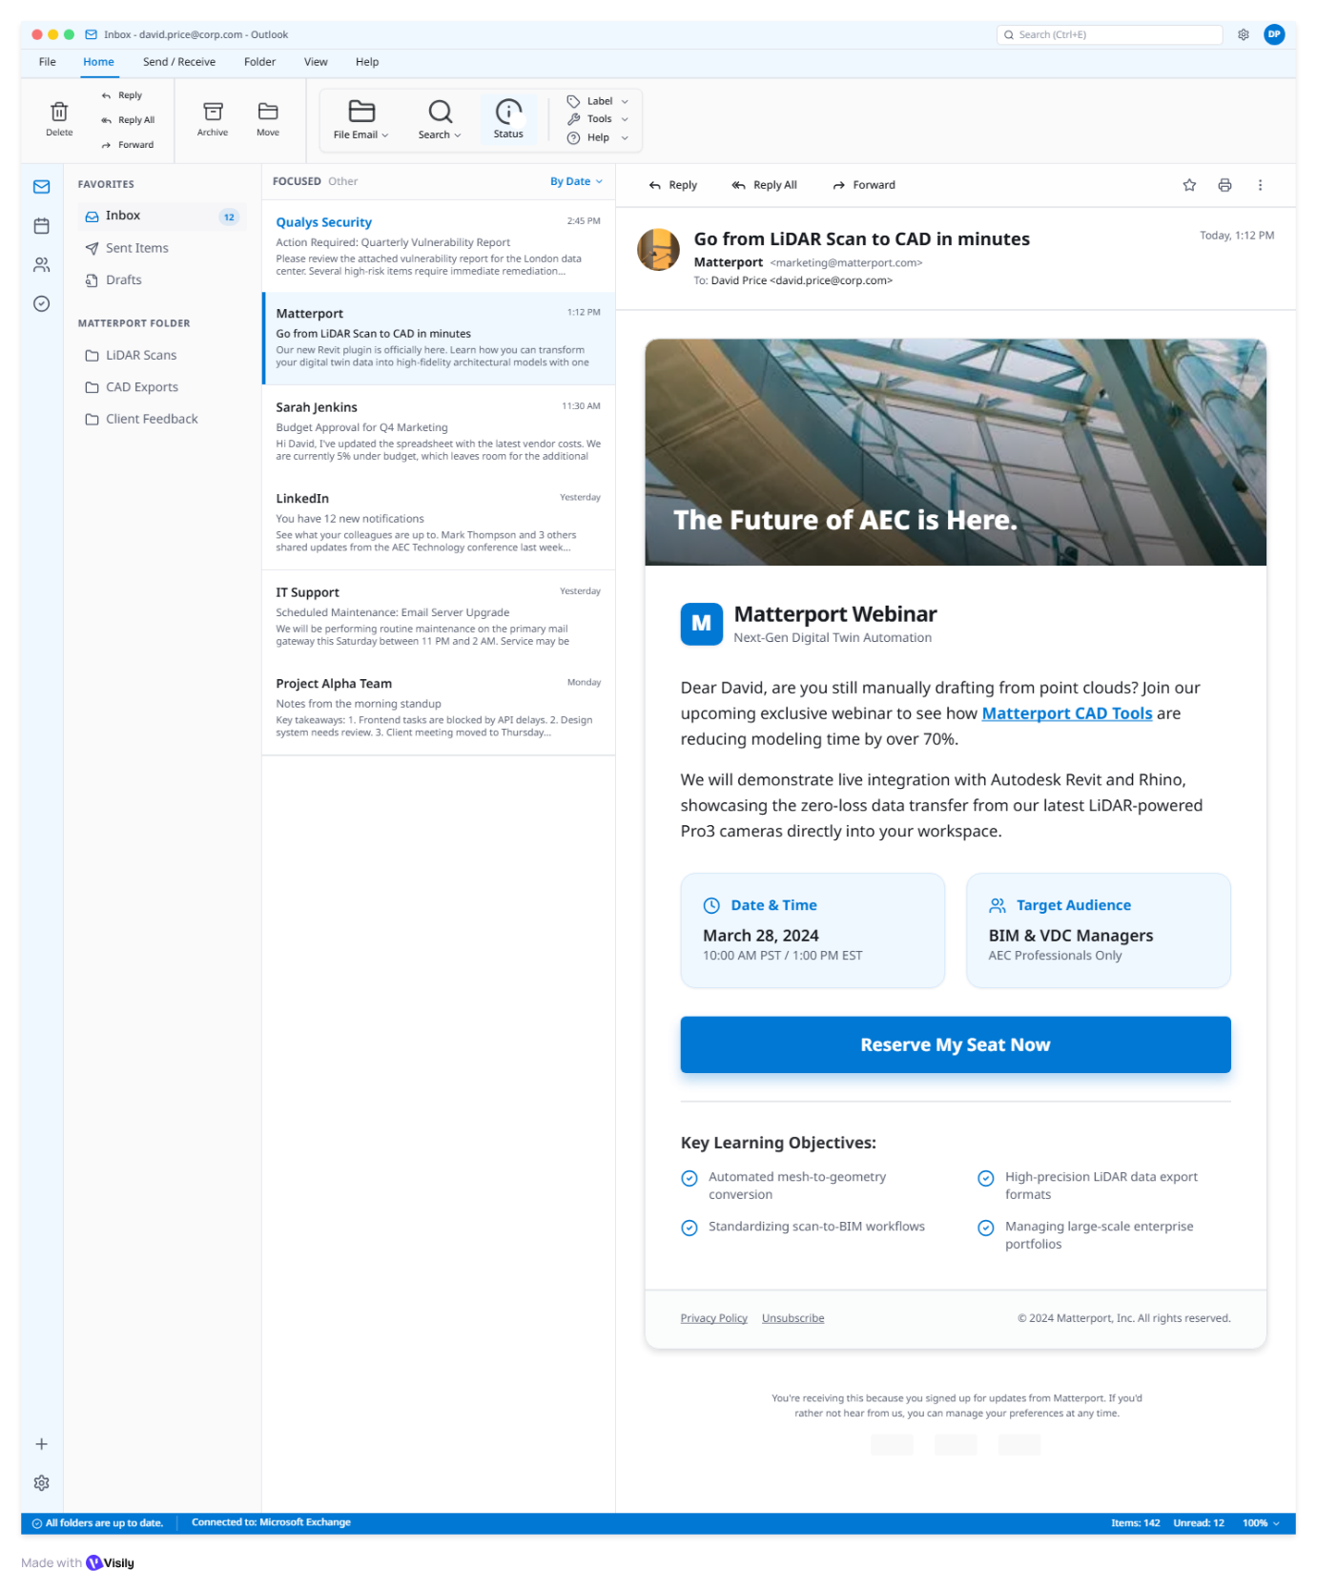

Email Filling Window
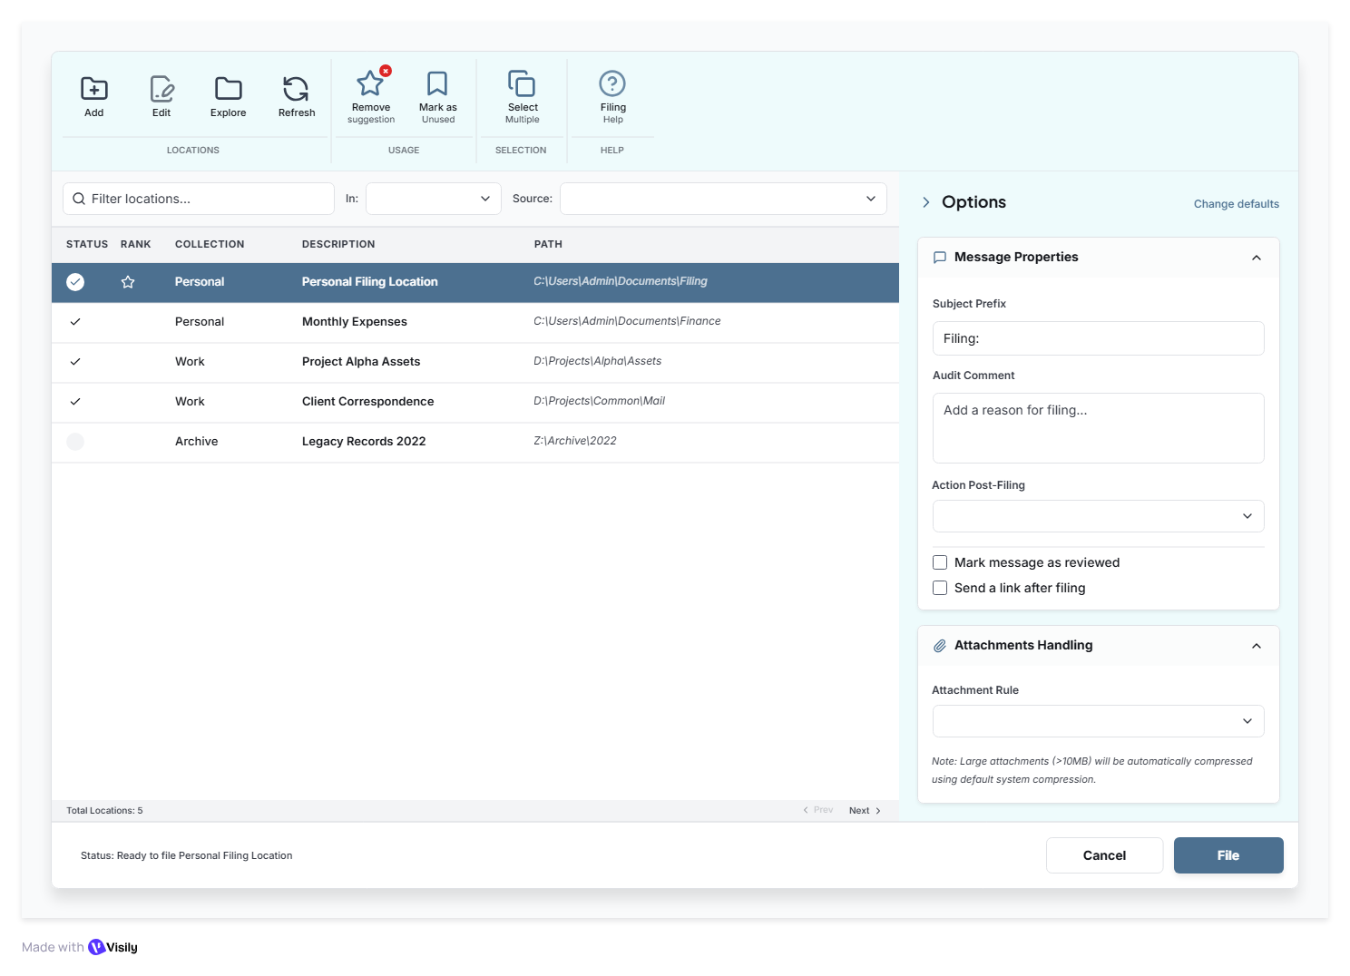

Add new Location
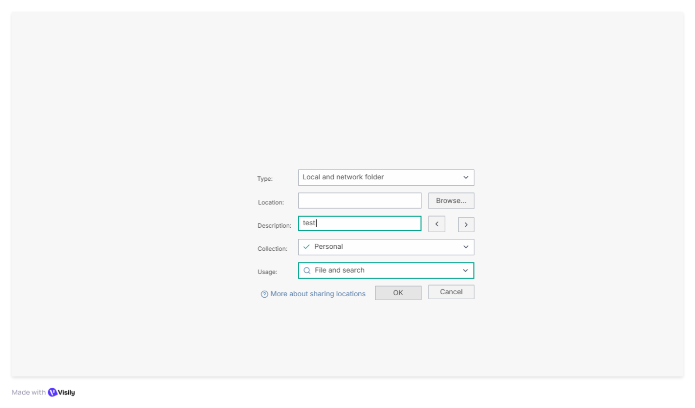

Search Screen
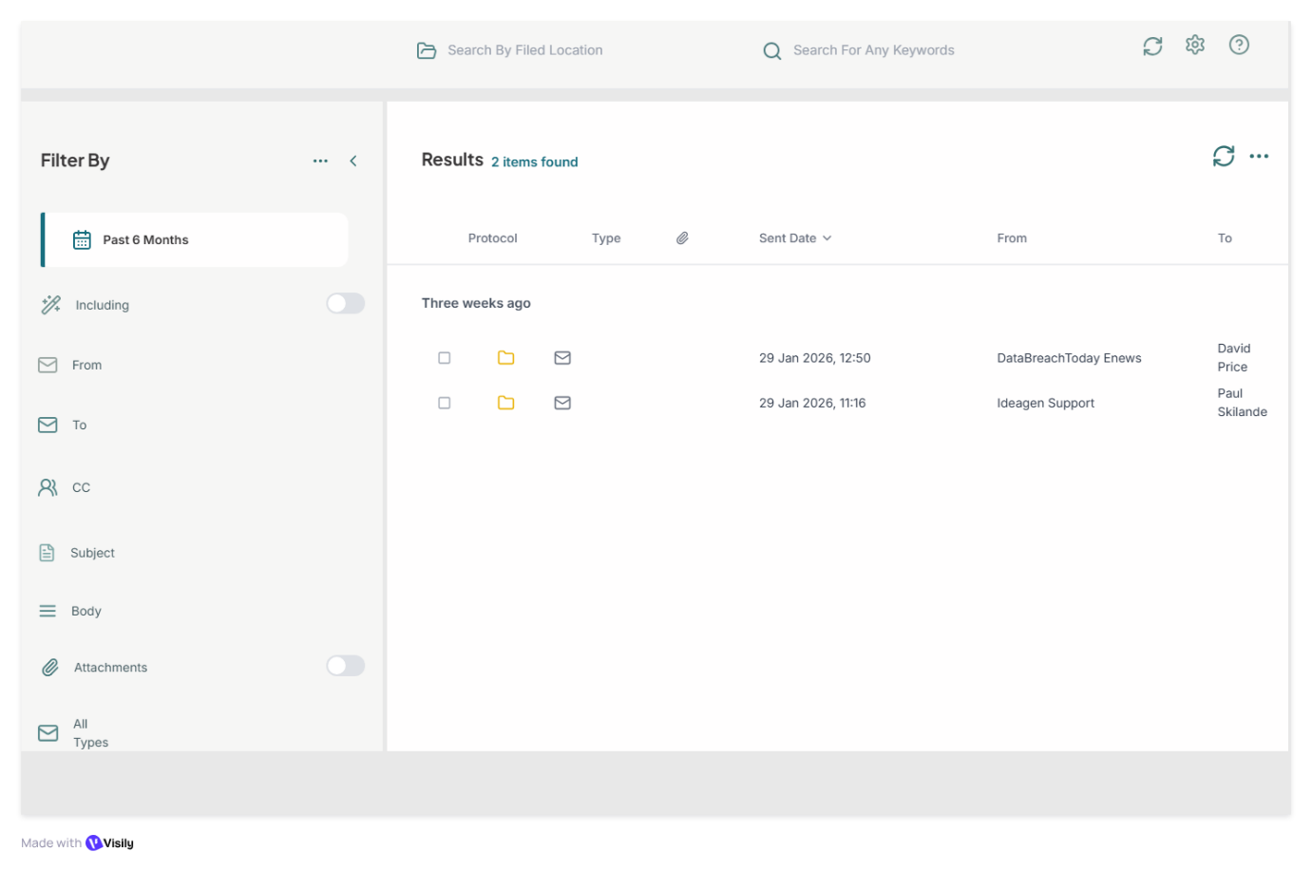

Options Screen
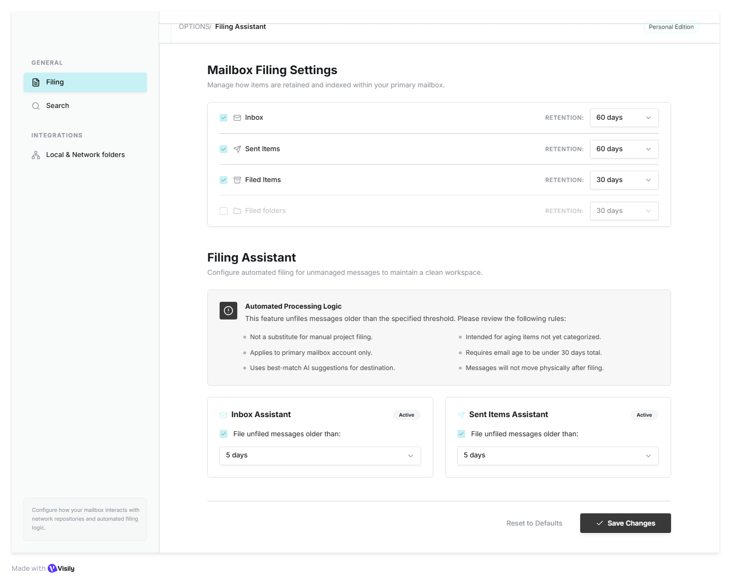

11. Expected Users
The system will support approximately 50 concurrent users, all accessing shared project folders on network drives.
The application must remain responsive and stable under this load.

Conclusion
This document defines the finalized functional and system requirements for Milestone 1 of the Outlook Email Filing Application. These requirements establish the scope, architecture, and operational behaviour of the system to ensure reliable email filing, efficient search functionality, and seamless integration with Outlook.
Future milestones will focus on implementation.

